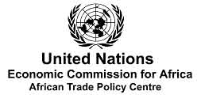 |  | 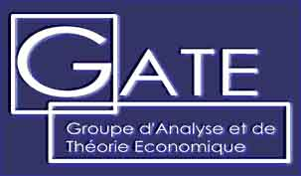 |  | 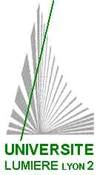

International Conference on
Economic, Social and Environmental Consequences
of the Liberalization of Trade in North Africa
and the Middle East

October 19-20, 2007
Rabat (Morocco)

Organised by
United Nations Economic Commission for Africa
GATE (Groupe d’Analyse et de Théorie Economique), CNRS, University Lyon 2, France

REGISTRATION FORM
(to be compulsorly returned to us)

Due date for this registration form : June 30, 2007

To register, please fill-in this form and send it by e-mail to:
Lahsen.Abdelmalki@univ-lyon2.fr
and Msadni-jallab@uneca.org

LAST NAME : ……………………………………… FIRST NAME :………………………………….....

TITLE : ………………………………………………………………………………………………......

INSTITUTION : ………………………………………………………………………………………....

ADDRESS : ………………………………………………………….......................................................

…………………………………………………………………………………………………................

POSTAL CODE : ………………………………… CITY : …………………………..………....................

COUNTRY.................................................................................................................................................

PHONE : …………………………………….FAX : ……………………………………........................

EMAIL : ………………………@..............................................

